**Introduction:**

This Steganography Program hides a text message inside a UTF-8 text file. It uses program Stegano.py to hide the data in the text file and Extract.py to extract the hidden message from the file.

The data is hidden in the following way:

* Text messages may be composed of letters, numbers, or a few special characters.
* - These encoded messages will be inserted into a carrier, and may later be retrieved.
* - The text representation will be 6-bit characters (6-bit chunks), where:
* The letters “A” through “Z” are encoded with values 1 through 26,
* The numbers “0” through “9” are encoded with values 27 through 36,
* “.,-”, space, are encoded with 37, 38..
* And any other characters you wish may occupy the remaining values (up to 2^6-1 = 63)
* - Every N’th bit of the carrier will be replaced with the next, sequential, bit of the text message.
* - The message length times N must be less than (or equal) the carrier length.
* - Then,   provide a method where, given the modified carrier and N can extract the text message.

**Please note:** It only allows Hidden message as <10 alphabets name> ‘Space’ <10 digit Number> ’dot’.

Example: “Hellenkell 1890123555.”

Please ensure that the original file has text file format and has UTF-8 encoding.

Stegano.py runs on the command prompt and requires an original text file with encoding “UTF-8”. It requires user to input the hidden message in the above format. Once data is provided, it creates a Stegano.txt (a text file which is replica of original text file but with hidden data) in the same folder.

To extract the data Extract.py is used. It runs on command prompt and extracts the data hidden in the Stegano.txt file. It displays hidden message on the command prompt.

**Folder includes the following:**

1. Stegano.py

2. Extract.py

3. Original.txt

4. Stegano.txt

5. Steganography Assignment-Read me.docx

1. **Stegano.py is program to hide the text message in a text file. Please follow the following steps:**
2. Stegano.py is a command line program and built using Pycharm with python version 3.0.
3. Open the command prompt and navigate to the folder where the program is stored.

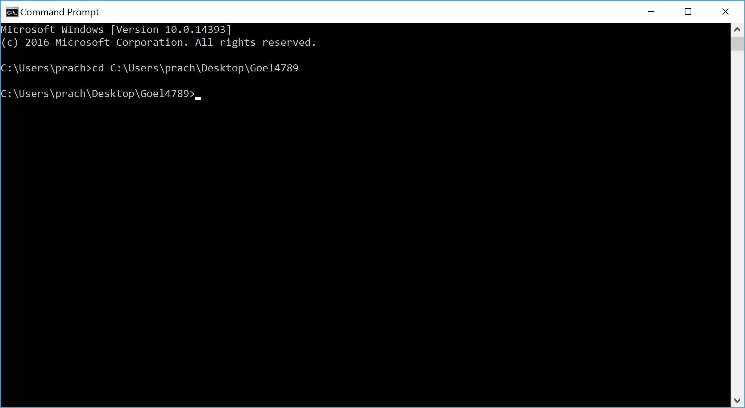

1. Ensure that the text file that would be used to hide the data should be present the same folder.

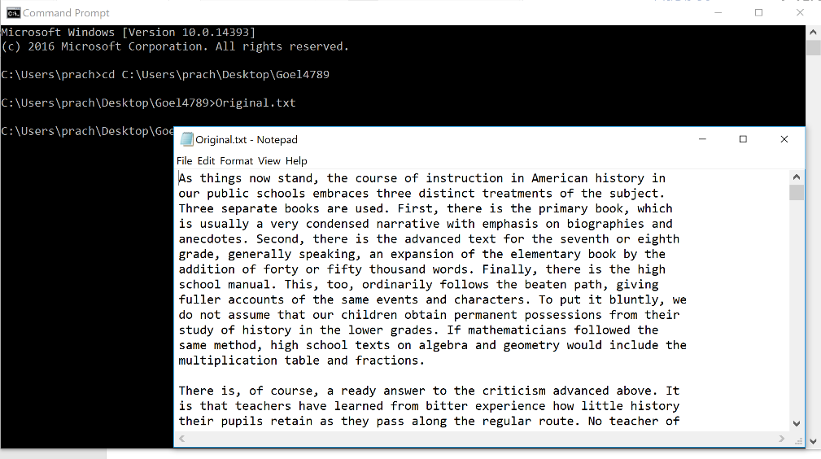

1. Type the name of the program and enter. The program will ask you to enter a name of 10 alphabets.

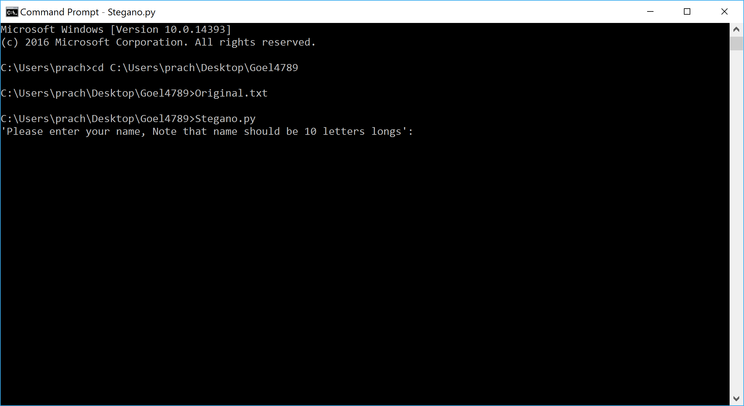

Example:

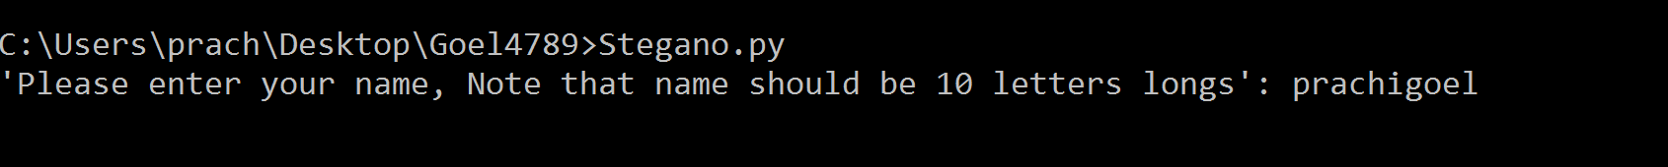

1. After the name is entered it will ask to enter 10 digits “Student Id”

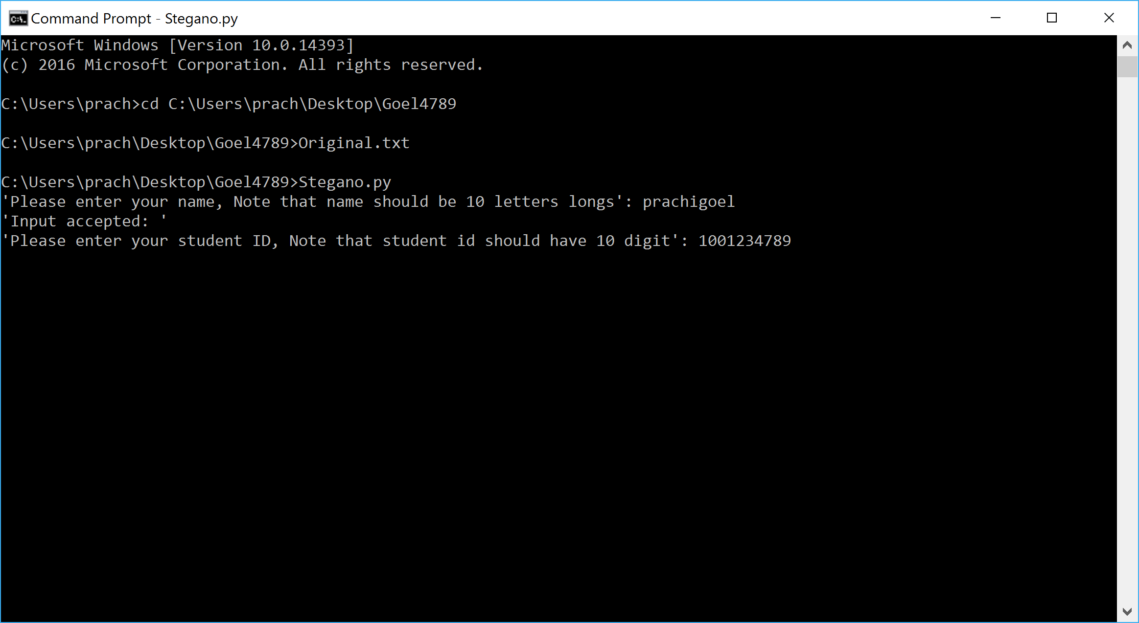

1. Your message will be hidden as <Name>’space’<Student ID>’.’

Example: prachigoel 1001234789.

1. Once you hit enter your message. A new text file will be created in the same folder as your program with name Stego.txt and a message will be displayed for the same.

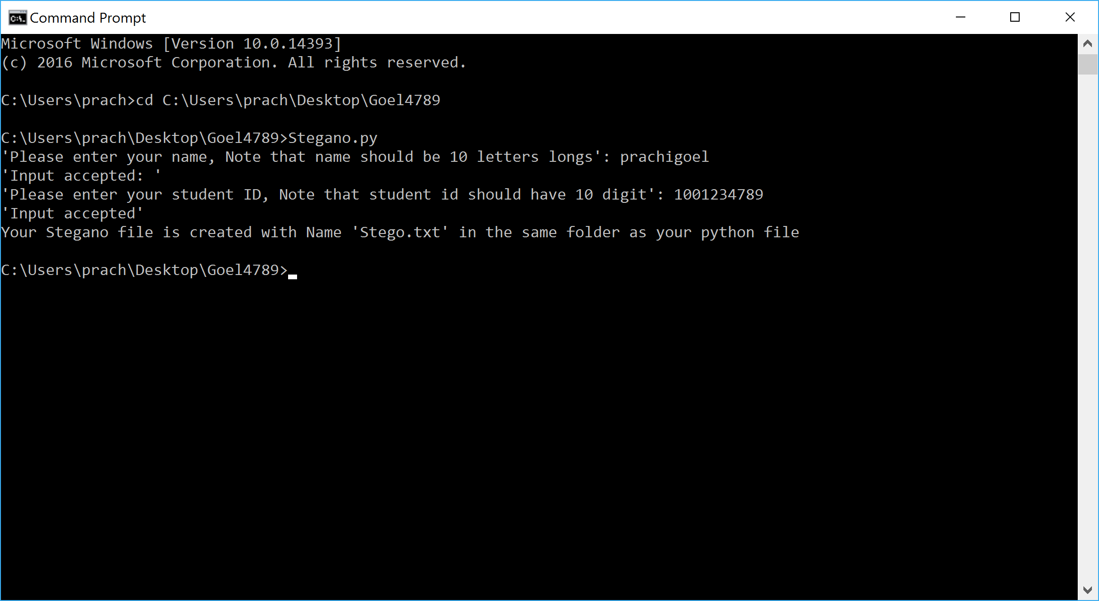

1. Difference in the two text files:

**Original Text (**Original.txt**)** **Text after hiding data.** (Stegano.txt)

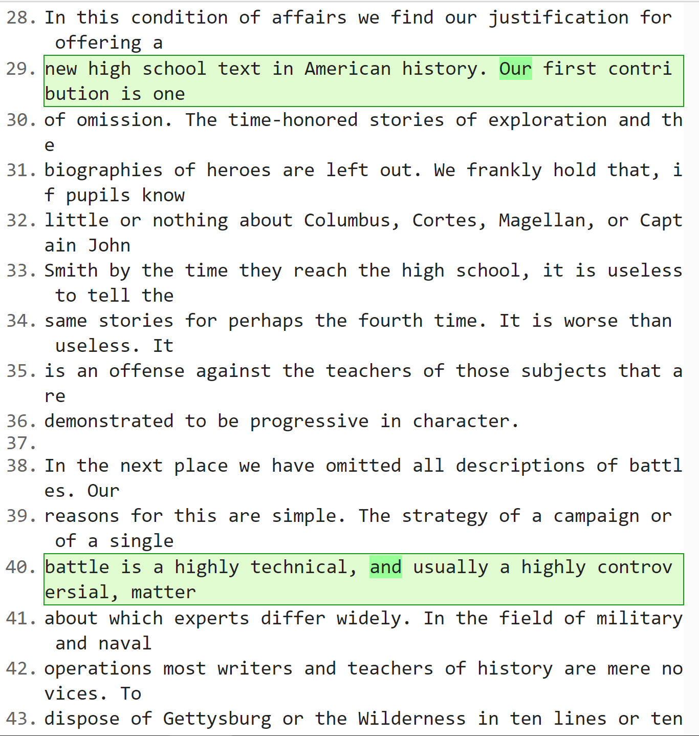 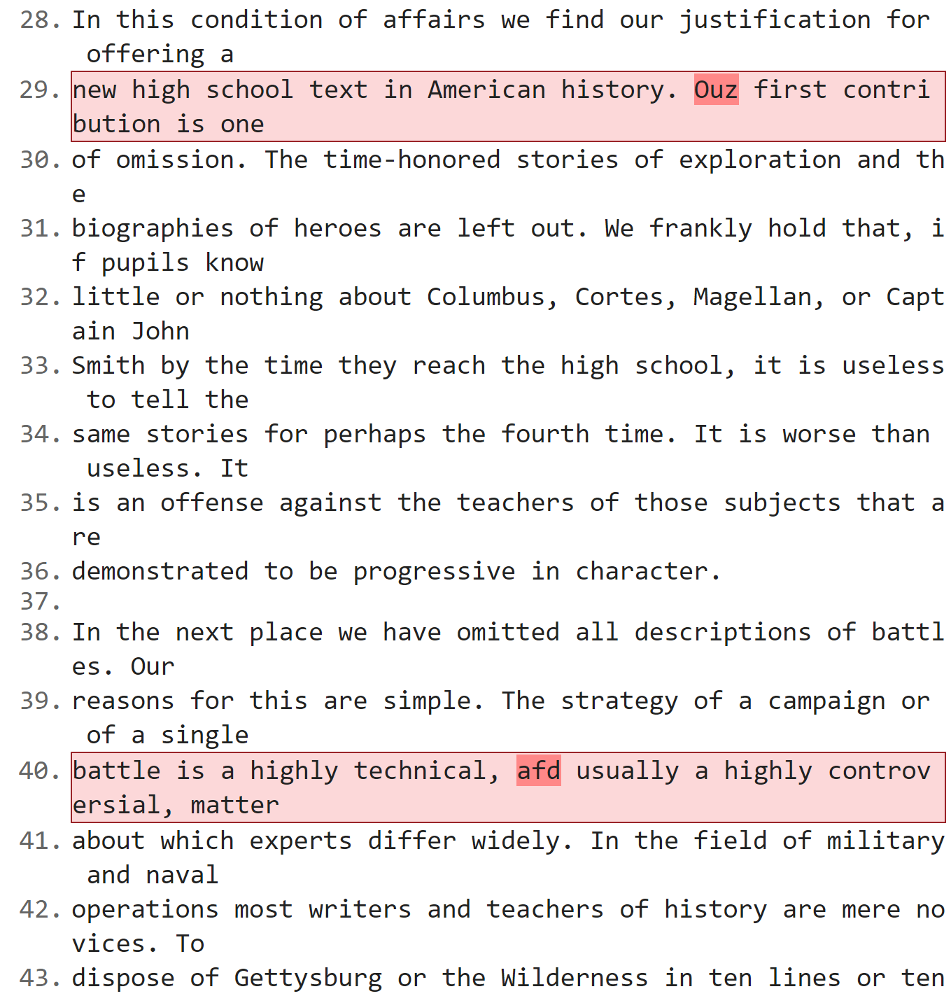

1. **Extracting the message from the text file uses the program ‘Extract.py’**:
2. Place the text file in the same folder as your program ‘Extract.py’

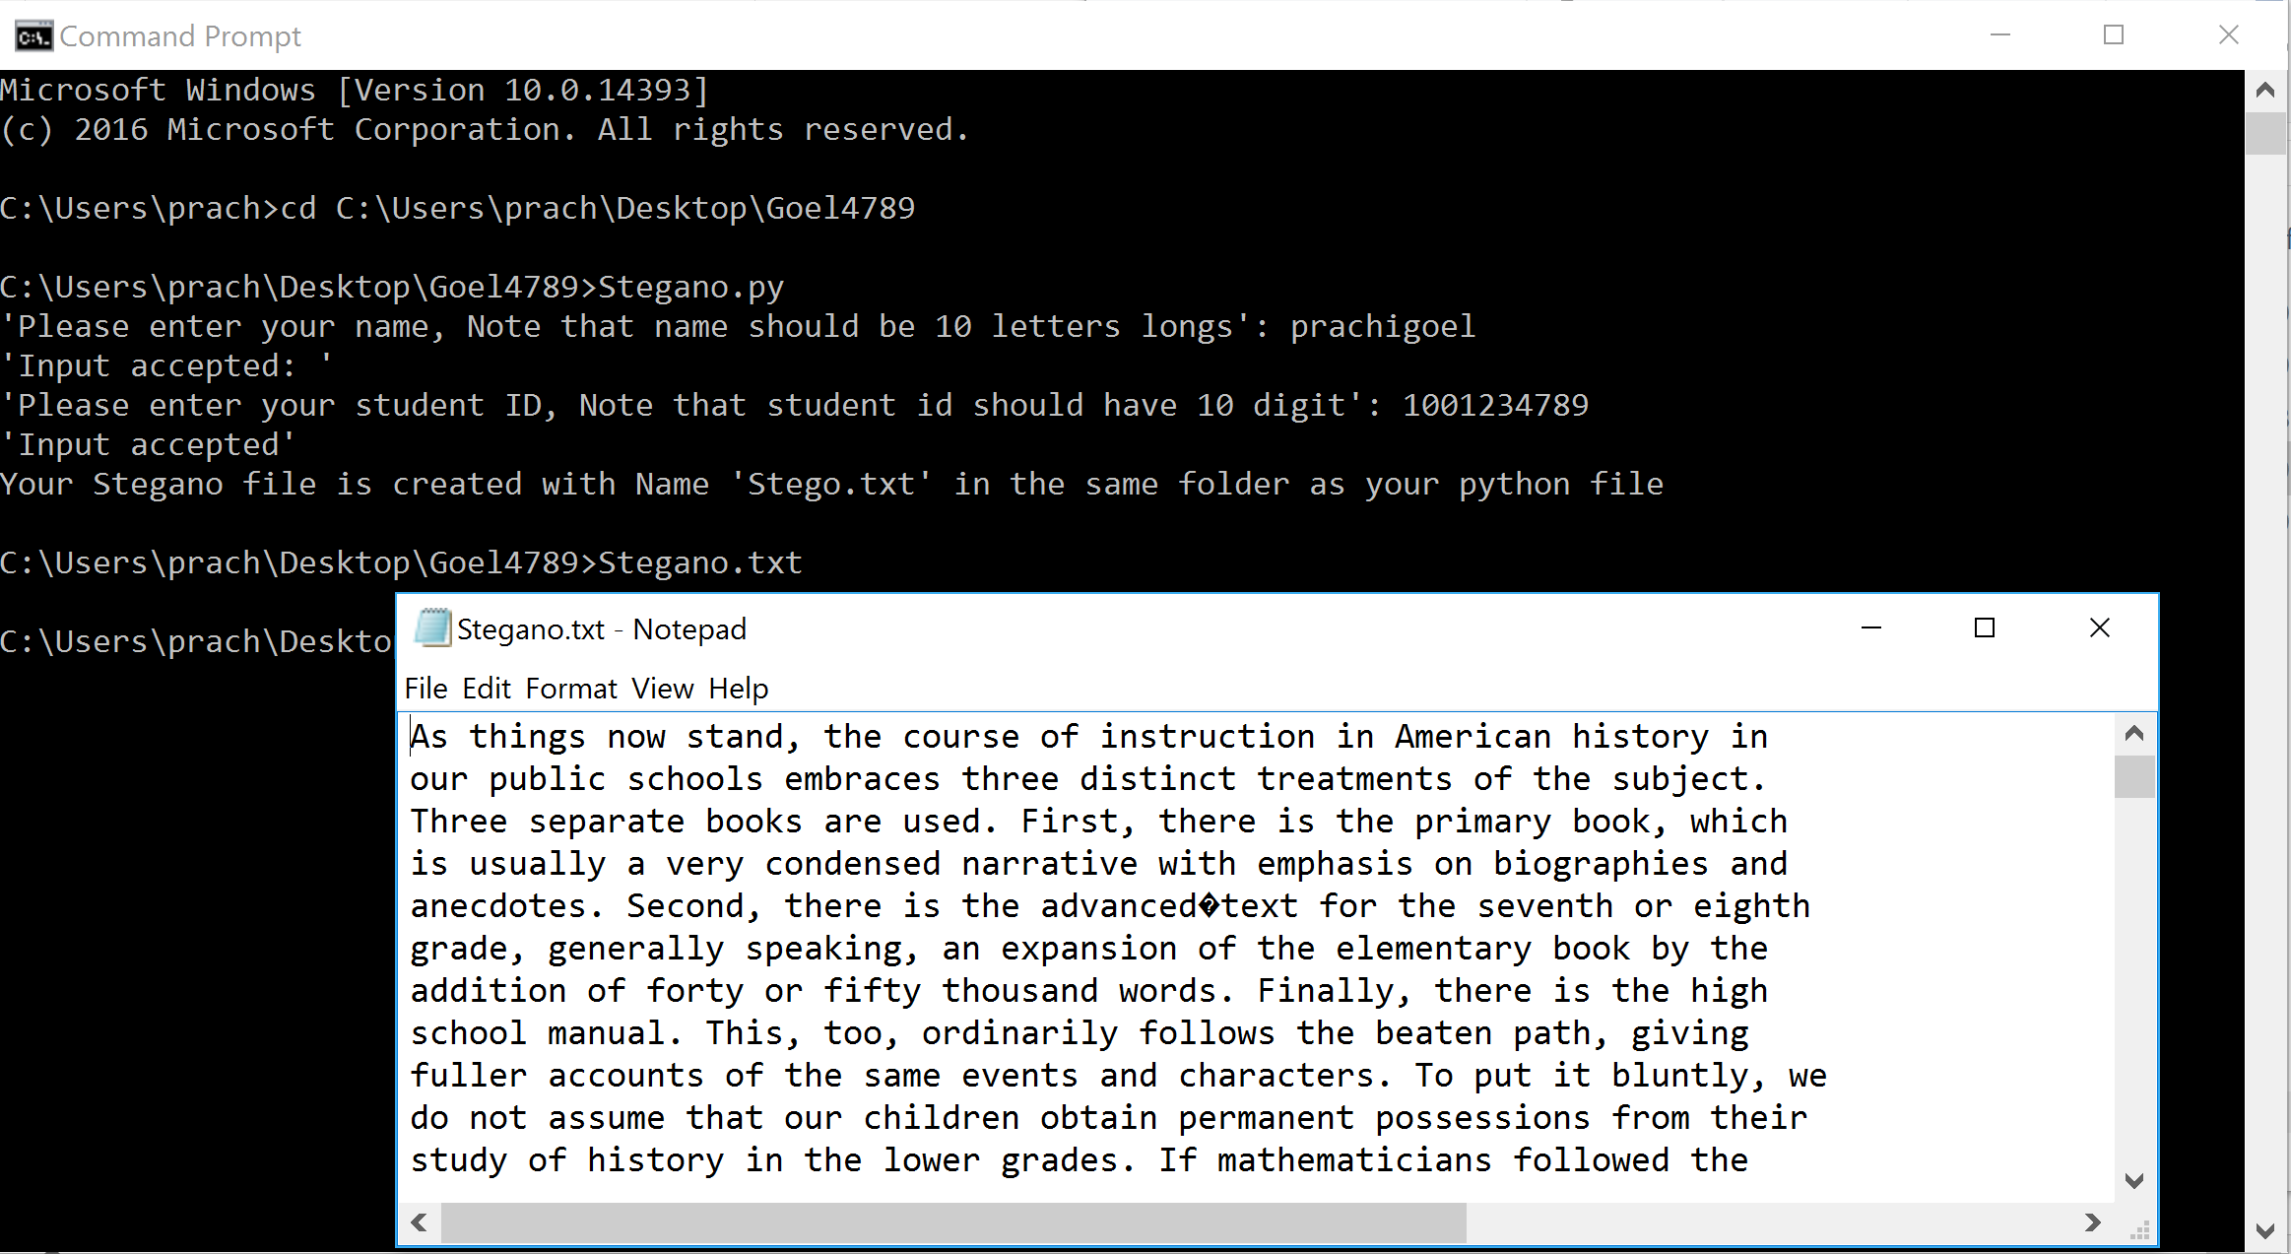

1. Enter the name of the program as Extract.py in the command prompt.

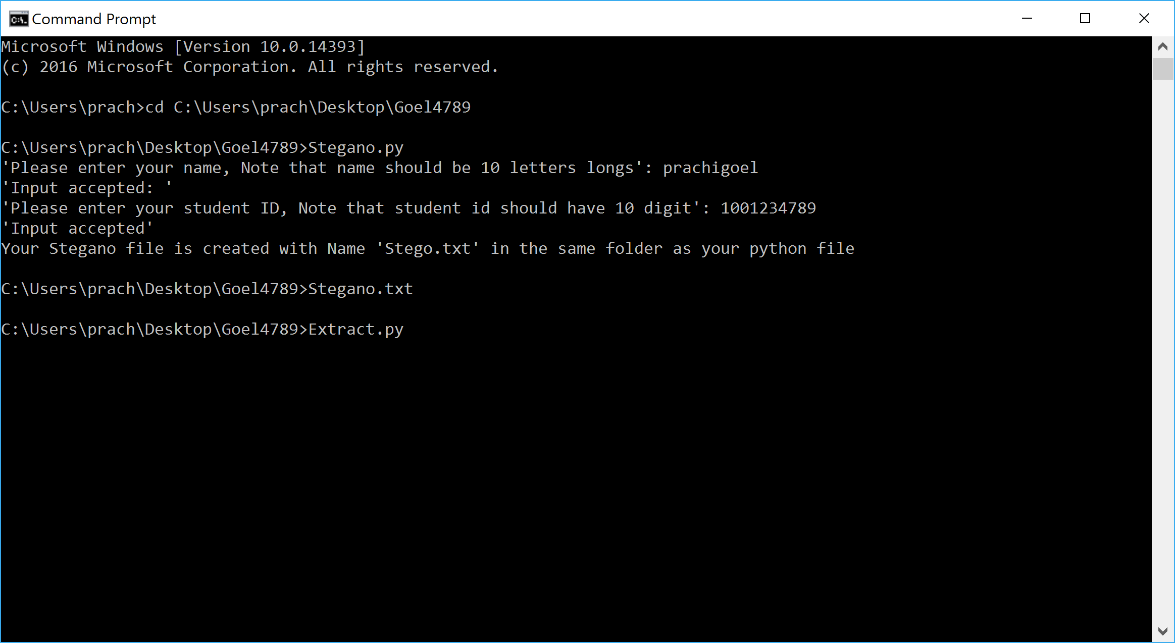

1. As soon as one hits enter it will extract the data from the provided Stego.txt file.
2. Message will be displayed on the screen:

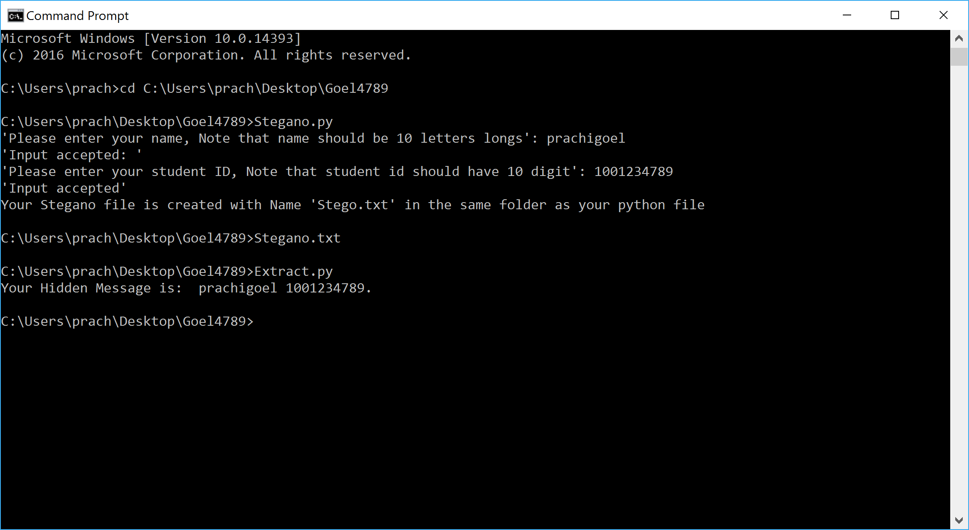

-------------------------------------------------------------End-------------------------------------------------------